RESOLUTION NO.__________

RE: CERTIFICATE OF APPROPRIATENESS UNDER THE
PROVISIONS OF THE ACT OF THE PENNSYLVANIA
LEGISLATURE 1961, JUNE 13, P.L. 282 (53
SECTION 8004) AND BETHLEHEM ORDINANCE NO.
3952 AS AMENDED.

WHEREAS, it is proposed to install a storm door at the front entry of
425 First Avenue

NOW, THEREFORE, BE IT RESOLVED by the Council of the City of Bethlehem that a Certificate of Appropriateness is hereby granted for the proposal.

Sponsored by: (s)

(s)

ADOPTED BY COUNCIL THIS DAY OF

(s)
President of Council

ATTEST:

(s)
City Clerk

HISTORICAL & ARCHITECTURAL REVIEW BOARD

APPLICATION #3: The applicant proposes to install a storm door at the front entry of 425 First Avenue.

OWNER: Jill Stark
425 1st Avenue, Bethlehem, PA 18018
__________________________________________________________________

The Board upon motion by Beth Starbuck and seconded by Holly Sachdev adopted the proposal that City Council issue a Certificate of Appropriateness for the following:

- Install a wood custom made storm door.

2. Top of the lock rail of storm door to match the bottom of the glass panel on the
front door.

3. To use brass hardware with three hinges and round or lever knob.

4. The motion was unanimously approved.

__________________________________________________________________________

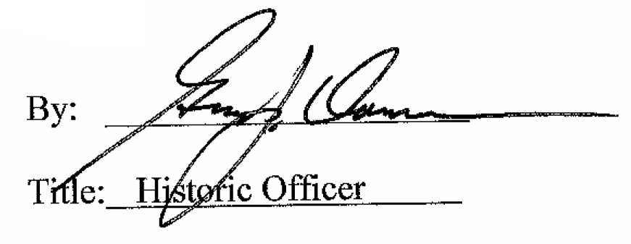

Date of Meeting: January 7, 2015

